About page edits:

In last paragraph, in the third sentence, change “(her home on the Mississippi…” to read “(my home on the Mississippi…) 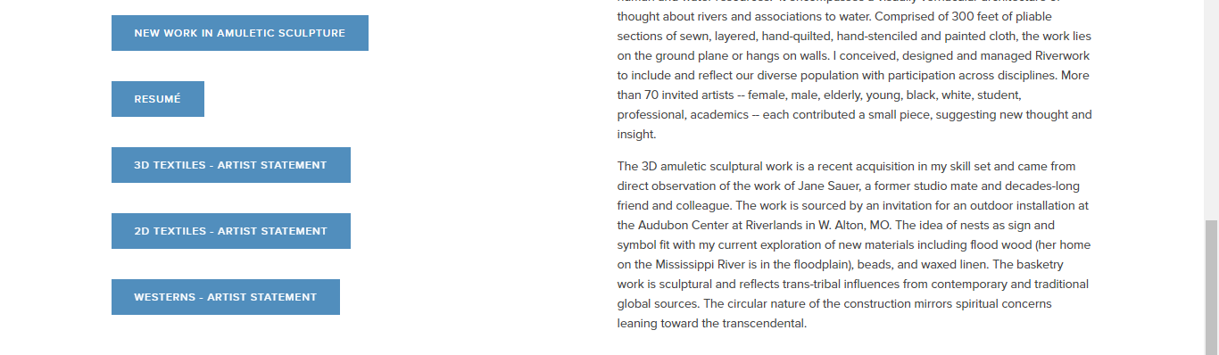

- Change 3D TEXTILES link label to:
Amuletic Sculpture – Artist Statement

Replace text with file: Amuletic Sculpture Artist Statement Feb 2020.doc

- Change 2D TEXTILES link label to:
Textile Art – Artist Statement

Replace text with file: Textile Art Artist Statement Feb 2020.doc

- Remove WESTERNS – ARTIST STATEMENT link from About page

Place copy on the Westerns gallery page and shift images to right (as done in Riverwork Project page). Delete “Works inspired by Westerns. To view larger, click…”

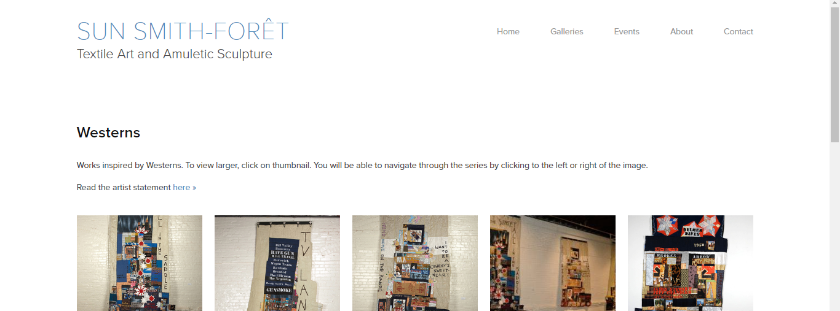

On Riverwork Project page in Galleries, delete the last sentence in the last paragraph of Riverwork Project text:

On all gallery landing pages (Soma Bay shown below for reference), replace “Trans-tribal Sculptural Objects” label with “Amuletic Sculpture” and link to Amuletic Sculpture Artist Statement Feb 2020.doc

